“Heaven’s light is our guide”

**Rajshahi University of Engineering & Technology**

Department of

Computer Science & Engineering

**Course No: CSE 3110**

**Course Title: Microprocessors and Assembly Language Sessional**

**Lab Report (Lab 1)**

|  |  |
| --- | --- |
| Submitted By:  ***Saifur Rahman***  *Roll No:* ***1703018***  *Section: ’17-A*  *Class: 3rd year (Odd Semester)* | Submitted To:  ***Sadia Zaman Mishu***  *Assistant Professor,*  *Dept. of CSE,*  *RUET.* |

***Date of Experiment: 19thJanuary, 2021***

***Date of Submission: 25th January, 2021***

Experiment no: 01

Name of the experiment:

**Case Conversion of Three Initials of a Person’s Name.**

Objectives:

Writing an assembly program to

* Prompt the user for three characters input
* Read those characters
* Display them down the left margin
* Convert case from uppercase to lowercase

Code:

1. .MODEL **SMALL**
2. .**STACK** 100H
3. **.DATA**
5. **CR EQU 0DH**
6. LF **EQU** 0AH
8. MSG1 **DB** 'ENTER THREE INITIALS OF YOUR NAME: $' *;user prmopt message*
9. MSG2 **DB** 0DH, 0AH, 'INITIALS OF NAME IN LOWERCASE: $' *;output message*
10. **MSG3 DB 0DH,0AH,'$' *;new line string***


14. .**CODE**
15. **MAIN PROC**
17. *;initialize DS*
18. **MOV** **AX**, @**DATA** *;get data segment*
19. **MOV** **DS**, **AX** *;initialize DS*
21. *;print user prompt*
22. **LEA** **DX**, MSG1 *;get first message*
23. **MOV** **AH**, 9 *;display string function*
24. **INT** 21H *;display string*
26. *;input and store characters*
27. **MOV** **AH**, 1 *;read character function*
28. **INT** 21H *;read first initial*
29. **ADD** **AL**, 20H *;convert it to lowercase*
30. **MOV BL, AL *;store it to BL***

33. **MOV** **AH**, 1 *;read chatacter function*
34. **INT** 21H *;read second initial*
35. **ADD AL, 20H *;convert it to lowercase***
36. **MOV** **BH**, **AL** *;store it to BH*
38. **MOV** **AH**, 1 *;read chatacter function*
39. **INT** 21H *;read third initial*
40. **ADD AL, 20H *;convert it to lowercase***
41. **MOV** **CL**, **AL** *;store it to CL*
43. *;print the initials*
44. **LEA** **DX**, MSG2 *;get output message*
45. **MOV AH, 9 *;displaying string function***
46. **INT** 21H *;diplaying string*
48. **LEA** **DX**, MSG3 *;get newline*
49. **MOV** **AH**, 9 *;display string function*
50. **INT 21H *;display new line***
52. **MOV** **AH**, 2 *;read character function*
53. **MOV** **DL**, **BL** *;display the first initial*
54. **INT** 21H
56. **LEA** **DX**, MSG3 *;get newline*
57. **MOV** **AH**, 9 *;display string function*
58. **INT** 21H *;display new line*
60. **MOV AH, 2 *;read character function***
61. **MOV** **DL**, **BH** *;display the second initial*
62. **INT** 21H
64. **LEA** **DX**, MSG3 *;get newline*
65. **MOV AH, 9 *;display string function***
66. **INT** 21H *;display new line*
68. **MOV** **AH**, 2 *;read character function*
69. **MOV** **DL**, **CL** *;display the third initial*
70. **INT 21H**

73. *;DOS exit*
74. **MOV** **AH**, 4CH
75. **INT 21H**
77. MAIN ENDP
78. END MAIN

Output:

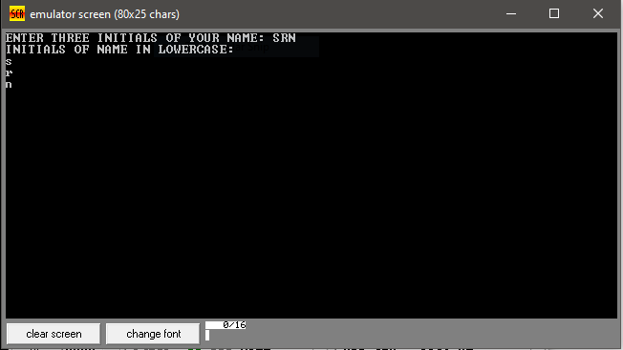

Discussion:

In this program, the data segment consists of three messages. A message for user prompt, another for output and the other one is newline. The code segment first shows the messages to user and prompt the user three characters which are the initials of a person’s name. Then each character is converted into lowercase and stored in 8-bit resistors. After that the characters are displayed with a carriage return and line feed which is to execute a newline between them. So that they are printed in left margin.